**UC Berkeley undergraduates’ general mental health and use of mental health services**

Shengyi Wu

**Introduction:**

Throughout my two years in college, more and more students around me say that they are suffering mental health problems such as anxiety, depression, bulimia, and obsessive-compulsive disorder. Indeed, according to the Counseling Center Directors’ Survey in 2014, there is a nationwide agreement that college students are having increasingly severe psychological problems year by year. However, when I asked my friends who suffer mental illness whether they have tried any mental health services on campus, the responses that I got were consistent: no. Through this research, I investigated UC Berkeley undergraduates’ general mental health condition and the use of on campus mental health resources. Using data collected through a questionnaire, I analyzed students’ general mental health and why they don’t use mental health services.

**Methodology:**

**Participants:**

The sample consists of 221 UC Berkeley undergraduates, with a grade distribution as follows: 19.9% freshmen, 52.5% sophomores, 15.4% juniors, and 12.2% seniors. 69.2% of participants are identified as female, and 30.8% male. In terms of ethnicity, 71.5% were Asian/Pacific Islander, 20.8% White, 5.9% Hispanic or Latino, 0.9% Black or African American, and 0.9% Other.

**Procedure:**

I designed a questionnaire which consisted of 16 questions, divided into three categories. Questions 1 to 4 asked general information, 8 to 11 about stress evaluation, and the last four about the use of mental health resources. The questionnaire is specific to UC Berkeley undergraduates, and was distributed through social media such as Facebook and WeChat, classroom announcements, and club announcements. After finishing collecting responses, I used R and Python to clean the data, and RStudio, Excel, and Tableau to create data visualization.

**Results & Discussion:**

**Mental Health Condition:**



Figure 1

In the survey, two questions assess UC Berkeley undergraduates’ satisfaction level with their academic work and personal life. 33.9% and 47.1% of participants feel satisfied or extremely satisfied with their academic work and personal lives, respectively. On the other hand, 39% and 24.1% feel dissatisfied or extremely dissatisfied with their academic work and personal lives, respectively (Figure 1). The result shows that there are more students who are satisfied with their academic work or personal life than those who are dissatisfied. On the other hand, 23.1% more students are dissatisfied or extremely dissatisfied with their academic work than those who are dissatisfied or extremely dissatisfied with their personal life. Therefore, the dissatisfaction of academic work may have a larger negative contribution to the overall satisfaction of life.

Figure 2

When participants are asked whether they are comfortable with their present stress level, 33% of them respond “yes”, 32.6% are “not sure”, and 34.4% say “no”. Among those who are not comfortable with their current stress level, 64.5% feel extremely dissatisfied or dissatisfied with their academic work. 52.6% of those who are not comfortable with their current stress level feel extremely dissatisfied or dissatisfied with their personal life. Again, academics seems to be a greater contributor to stress. Additionally, for the question “Within the last 6 months, do you feel like any kinds of things have been traumatic or very difficult to handle?”, the three most popular types of difficulty are “Academics” (76.9%), “Career-related Issue” (50.7%), and “Intimate relationship” (36.7%). Figure 2 shows that among students in different years, “Academics” is always the most popular option and most juniors (85.3%) handling their academic work to be traumatic or difficult. These results consistently show that academic work is the most prevalent difficulty that UC Berkeley undergraduates have, and it has negative effect on students’ general life satisfaction and stress level.

Figure 3

In Fall 2016, the American College Health Association conducted a National College Health Assessment on 33,512 students at 51 different schools. Participants were asked the same questions about types of difficulties that they have. The comparison diagram Figure 3 shows that the percentage of UC Berkeley undergraduates who have difficulty in their academics is 28.5% higher than that of general U.S. college students. Also, more UC Berkeley undergraduates have difficulties in career-related issues, intimate relationships, other social relationships, and personal health issues than general U.S. college students. From these results, UC Berkeley undergraduates seem to experience more greatly different kinds of traumas and difficulties than students in other colleges, academics being by far the most notable.

Figure 4

In addition to identifying the types of difficulties that UC Berkeley undergraduates have, I also assessed students’ mental health disorders. According to Figure 4, 78.1% of participants in my survey indicate that they do not have any mental disorders. The three most common were anxiety (16%), depression (11.3%), and obsessive-compulsive disorder (5%). Figure 4 compares the condition of UC Berkeley undergraduates’ mental health problems with that of general U.S. college students. Except the percentages of Berkeley students who have eating disorder and obsessive compulsive disorder which are slightly higher, Berkeley has a lower proportion of students who suffer other mental health issues. Therefore, overall, fewer UC Berkeley undergraduates suffer mental health problems than students in other U.S. colleges.

**On-Campus Mental Health Services Uses:**

In the survey, one question asks participants to choose what kinds of mental health services they have used before. 145 out of 221 (65.5%) participants choose the most popular answer, which was “I have never tried any services before”. However, 96.8 of these participants suggest that they have felt “overwhelmed by all they had to do” at least once in the previous year. Additionally, 64.5% of those who are not comfortable with their current stress level have never tried any on-campus mental health services before. According to the survey results, undergraduates at Berkeley have higher overall stress levels and greater proportions traumatic difficulties than general U.S. college students. Why, then, do students not use mental health services on campus? To find an answer, I investigated the effect of students’ sociability the use of mental health services by students facing difficulties, and the proportion of effectiveness rating by students facing difficulties.

In order to evaluate the effect of students’ sociability on the use of mental health services, I divided the activities that 221 participants enjoy and actively participate in into two categories. “Attending church”, “Talking to friends or families”, and “Joining clubs” count as “social activities” because they involve communication with other people. Other activities such as “Playing computer games”, “Raising pets”, and so on are considered as “not social activities” as they don’t usually involve interaction between people. Additionally, I categorized mental health services into “counseling services”, which include “Short-term individual counseling by Tang Center”, “Drop-in counseling by Tang Center”, “Peer counseling by Student to Student Peer Counseling”, etc., and “not counseling services”, which include “Self-help & online resources by Tang Center”, “Pet Hugs event by University Health Service”, “Prevention & education related groups and workshops by Tang Center”, etc. “Counseling services” require people to talk about their problems with others, but students don’t need to talk about their issues for “Not counseling services”. If participants choose any “social activities”, they are counted as “social”. Otherwise, they are counted as “not social”. I wanted to see whether “social” participants were more likely to try “counseling services” than “not social” participants.

The result shows that among those who have tried any mental health services before, 5 out of 75 participants were “not social”, but all 5 have tried “counseling services” before. Although very few students did not engage in any social activities at all, being “not social” did not seem to stop them from trying counseling services. This may be because people who are “not social” may not have as large of a support group of friends to talk to, but counseling seems to be an acceptable method for them to talk about their issues.

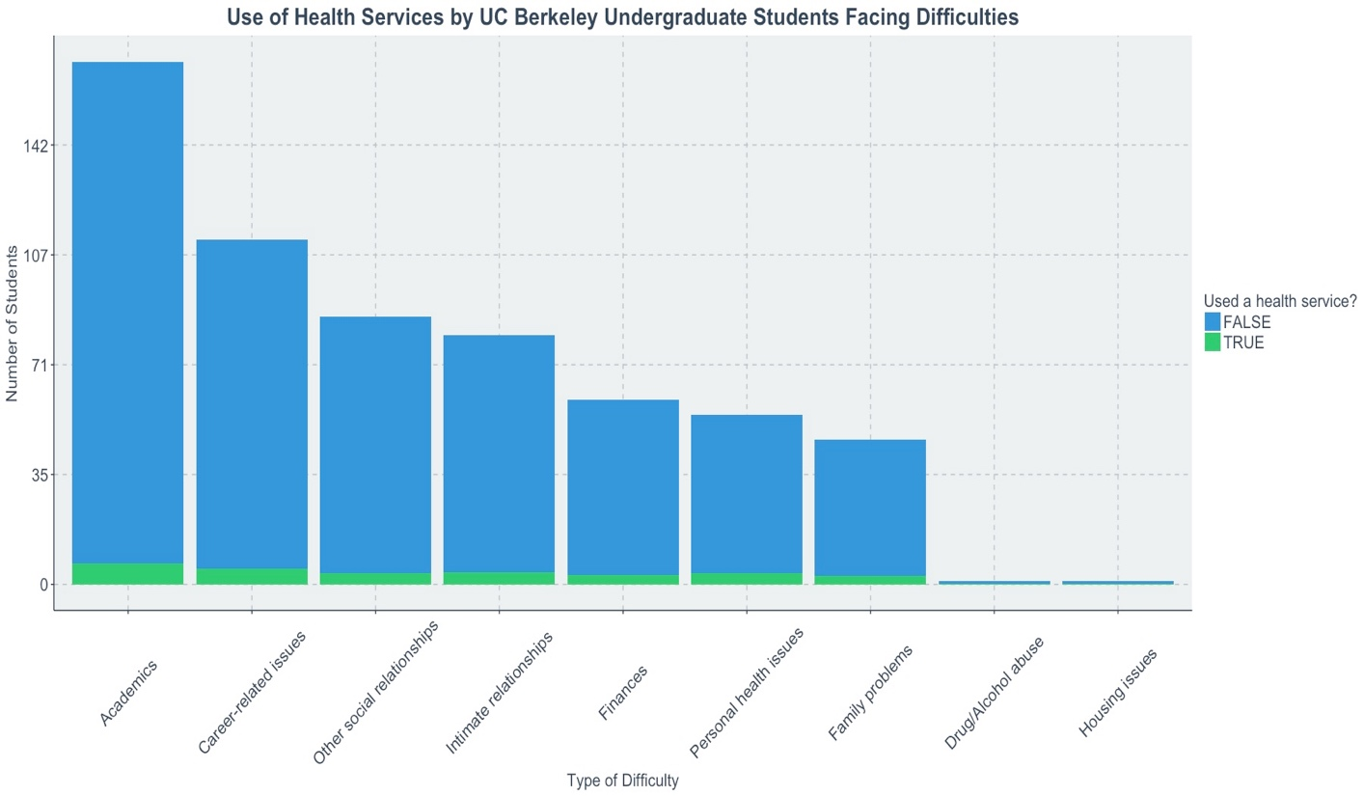

Figure 5

Additionally, I wanted to know students with what types of difficulty are more likely to try on-campus mental health resources. Figure 5 shows the number of people with each difficulty who have used on-campus mental health services before (green bars) or have not (blue bars). The result reveals that the number of those who have academic difficulty and have tried mental health services (6 people) is highest among all types of difficulties. For those who have career-related issues, 5 of them have tried the services before. However, these two difficulties have the most people total, and thus a much smaller amount of people who have tried resources proportionally. Compared to the much higher total number of students who experience traumatic difficulties, the number of students who actually tried the services is low. This may be due to the ubiquitous nature of academic and career difficulties; as they are so common, they may be normalized in campus culture to the extent that students feel as though academic and career difficulties are expected, and not problems to seek counseling for.

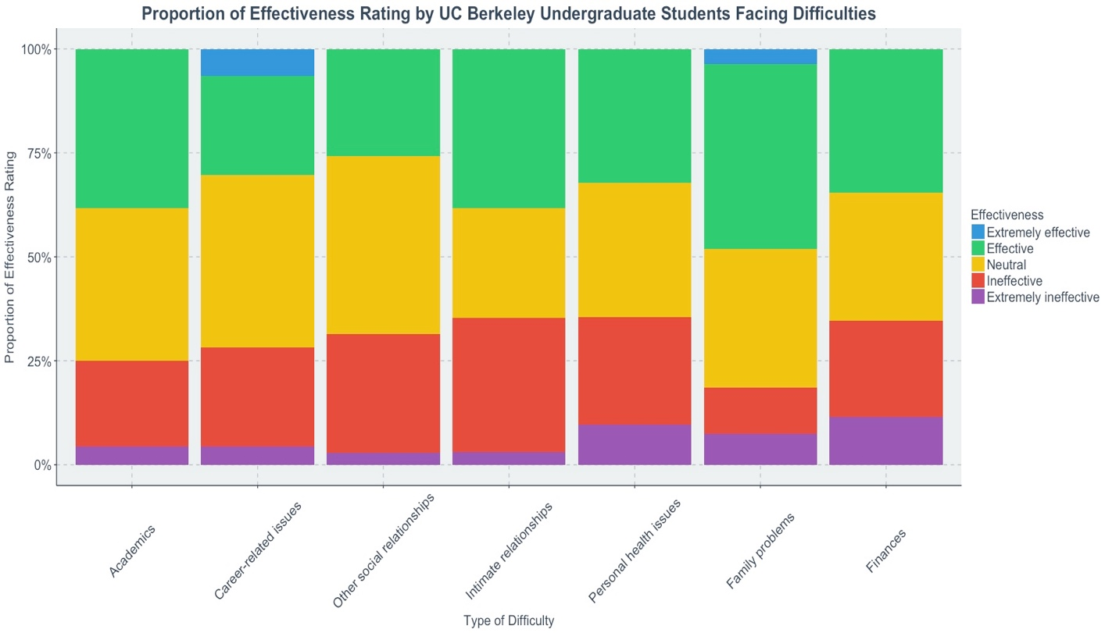

Figure 6

Students are more likely to use mental health services if they are effective. Overall, only 17.8% of participants find on-campus mental health services to be very effective or effective and only 19% of them think that the services are adequate. Specific to different types of difficulties, according to Figure 6, mental health services are most effective in solving family problems and intimate relationships. However, these are actually the least popular type of difficulty that UC Berkeley undergraduates suffer. Most people have academic problems and career-related issues. Therefore, the relative ineffectiveness of solving academic problems and career-related issues by on-campus mental health services make people with these questions not willing to try the services. As these two problems have become campus culture issues and there are not enough mental health resources to address these problems, the school and Tang Center should add more services that help students ease academic and career-related issues.

**Limitations:**

The sample size in my study is relatively small compared to the total number of UC Berkeley undergraduates. And, some options in some questions have very low responses, so the results based on these responses may be overstate or understate the problems. Therefore, the result that I got may not represent the situation of all UC Berkeley undergraduates. Also, the distribution of gender, year, and ethnicity in the sample doesn’t resemble that of all UC Berkeley undergraduates and the sample of 33512 students in National College Health Assessment. In my sample, the proportion of Asian students is much higher than the proportion of Asian among UC Berkeley undergraduates. Consequently, the result may not be representative for the whole population. What’s more, the results of survey may change if the survey is conducted at different time period throughout the semester because the stress level and types of difficulty that each student has keeps changing. As a result, the result may not be applicable for all year round.

**Conclusion:**

In conclusion, for UC Berkeley undergraduates, academic work satisfaction has the greatest effect on general life satisfaction and stress levels. Compared to students in other U.S. colleges, the proportion of UC Berkeley undergraduates that experience traumatic difficulties in academics, career-related issues, intimate relationships, other social relationships, and personal health issues is higher than that of general U.S. college students, but lower proportion of UC Berkeley undergraduates suffer mental health disorders. However, due to the low percentage of students who have sought counseling services, there may be students who have mental health disorders but have not been diagnosed.

What’s more, UC Berkeley on-campus mental health services are not widely used by undergraduate students. The sociability of students had apparently little effect on the likelihood that they would seek help from those services, and counseling is accepted by those who do not prefer social activities. On the other hand, the relative effectiveness of solving academic problems and career-related issues, which are problems that students are most likely to seek help for, is low. The Tang Center should carry out more effective mental health services specific to these problems and encourage more students to participate in these services. UC Berkeley must pay more attention to the academic and career-related problems that students have and initiate a change in the school culture that normalizes these problems.